READ ME FILE.
FRONT END-ASP.NET
BACK END-SQL-
Using the Sql database and Ajax to make connectivity given by the 4 main
CUID operations.
Create
Update
Insert
Delete

PROJECT- INSTANT MESSAGING SERVICE
Using .NET framework this application runs on web. Install Visual Studio on the system.
This project helps to send messages to individuals using cellular communication
and internet facility. All the group members are saved in database which makes it
easy to communicate with an individual.
FORMS-8 forms in this project namely
1. Login
2. Registration
3. Manage users
4. User details
5. Manage groups
6. Group detail
7. Send SMS1
8. Send sms2

The main Part in this project is use of Web request in the visual studio tool kit.
For this we buy a gateway online.
An eg. Technocityindia.com
A web request from the system to the server is send through this gateway by providing a url in the web config page.
The communication process takes place as shown in figure below

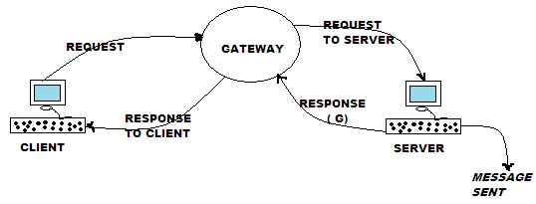

HOW TO USE THIS PROJECT
1.If the member is an authenticated user then the user can login into his/her account providing username and password.
2.In case member is anonymous he can create a new account using registration form
3.When the user has logged in,one can use all the forms
4.Manage User-this form helps to manage the students by performing CUID operations.
5.One can also view the user details.
6.Manage group-this form helps creating a new group and adding students in a particular group and manage the students.
7.SEnd SMS-One can search the user in the group and send him a particular message.
8.Once the desired process is completed,i.e message has been relayed one can log out.

